Homepage
- Logo: Supun Group of Companies logo needs correcting
- Remove: "A family-led group shaping everyday life through manufacturing, retail, distribution and hospitality."
Add: "One Sri Lankan Group, built across four industries since 1978."
- Video: crop out the shoe product display segment from the current placeholder video (old designs)
- Remove: "One group. Many possibilities"
- "Built in Sri Lanka. Built to Last." — move the color back to yellow
- "Explore our journey" button — make bigger and brighter

Our Legacy
- Remove: "One vision in Colombo became a group built across generations."
Add: "A legacy built over generations."
- Remove: "A family business with the courage to keep building."
Add: "A family-run business with the courage to keep building."

What We Do
- Remove: "A Sri Lankan group built on making things well."
Add: "A Sri Lankan group built across industries."
- Remove: "From our Colombo trading roots to manufacturing, retail, hospitality and homegrown consumer products, every capability strengthens the next."
Add: "From a single trading company to four industries today: manufacturing, retail, distribution, and hospitality, each one held to the same standard."
- Hospitality card copy to be changed: "Supun Arcade Residency and Area 56 bring hospitality to central Colombo, from luxury serviced apartments to first-class rooftop dining above the city."
- Camy card copy to be changed: "Camy is Supun Group's own consumer durables brand, designed and manufactured in Sri Lanka for Sri Lankan homes, spanning household appliances and everyday electronics."

Inside the Group
- Replace: "Businesses built for impact."
With: "The businesses behind Supun Group"
- Company display order: Supun Traders, Supun Super Center, Supun Arcade Residency, Camy Global etc
- Replace: "Meet all 11"
With: "Explore our companies"

Homepage footer
● Remove entirely: "A family-run Sri Lankan group with roots dating to 1978, operating across manufacturing, retail, distribution and hospitality."

ABOUT US
Our Story
● Change "household goods" to "household appliances and electronics"

Leadership Team
- Raiza Kaleel — description: "Oversees the Camy brand and Group marketing."
- Lasitha — description: "Oversees financial strategy, treasury, compliance, and governance across the Supun Group."
- Jeewantha — title: "Head of Hospitality & Business Development"
- description: "Oversees hotel operations, guest experience, and business development across Supun Arcade Residency and Area 56."
- Eranga — description: "Oversees plastic injection moulding and manufacturing operations at Rodsons."

Awards Section
- Reorder so the Made in Sri Lanka awards appear first
- Redesign the section visually - see how we can best lay this out
- Awards to also come under News & Media — I will give the blogs

- Can we design the below section a bit better
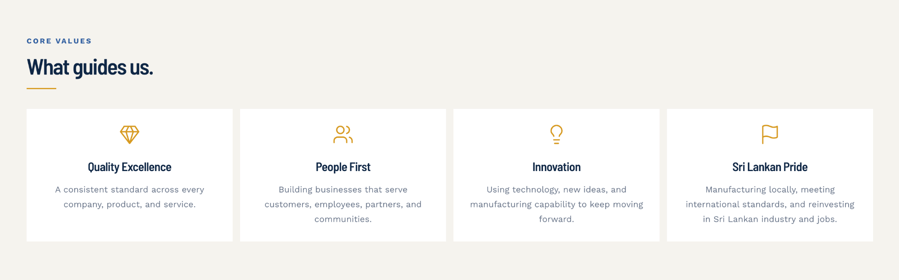

- Under awards - put the made in sri lanka awards first and can we design this section also a bit better.
- The awards can also be put under the news and media section - I'll give the blog posts for this soon.

OUR COMPANIES
● General rule for all company pages - Each page should carry only one tagline — remove duplicates wherever they exist

● Supun Traders
Tagline: remove "Where the Group Began" → replace with "The Group's original wholesale and retail business, trusted since 1978."
Body copy: replace with — "Supun Traders is where it all started. Founded in 1978 by Mohamed Fareed, it began as a trading business importing and distributing household appliances and electronics, and grew into the foundation the Group stands on today. In 1999, his son, the current Chairman, Mr. Kaleel, took on that legacy and built it into what is now the Supun Group of Companies. Today, Supun Traders remains a trusted wholesaler and retailer of locally manufactured and imported household goods, home appliances, and electronics."
Key features: remove "Strong, long-standing supplier relationships"

● Supun Super Center
Tagline: remove "Colombo's Retail Destination" → replace with "The Group's Retail Destination."

● Supun Arcade Residency
Tagline: remove "Luxury Serviced Living in Colombo" → replace with "Luxury Serviced
Apartments in Colombo"
Remove second tagline "Rooftop dining atop Supun Arcade Residency" (page should carry the one tagline above only)
Body copy: replace with — "Supun Arcade Residency offers fully furnished,
air-conditioned suites in the heart of Colombo, each with panoramic ocean or city views. Above the city, a rooftop pool and dining space invite guests to unwind, backed by premium hospitality throughout the stay."
Key features: add "Rooftop pool and dining"

● Supun Aerosoft
Tagline is currently duplicated on the page — keep one
Key features: add "Made in our own factories in Sri Lanka"
● Aero Star
Keep tagline "Precision Chrome Plating for Camy Appliances" — remove the other one

● Camy Smart
Keep tagline "One of Sri Lanka's largest SLS-certified helmet manufacturers." — remove the other one
- Can we better design the below recognition sections

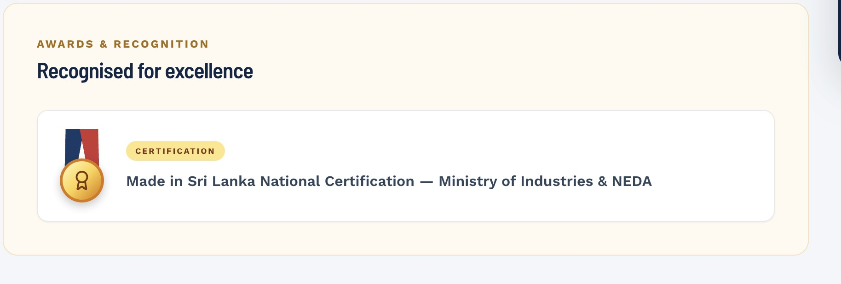

- Keep only explore the group- take off discover other companies


CAMY PRODUCTS PAGE
Headline: "PRODUCTS FOR EVERYDAY LIFE."

Logo: switch to the red Camy logo, sized larger so it's the first thing visible on entering the page - can we re-look at a different way to design this page?

Body copy: "Camy brings together a growing range of products for the home, the road and everything in between. Designed with purpose and shaped by an understanding of everyday needs, each product is backed by the manufacturing experience of the Supun Group."

Sub-block "DESIGNED WITH PURPOSE": "We focus on the details that make a product useful, how it fits into your routine, how it performs and how it feels to live with."

Sub-block "BACKED BY EXPERIENCE": "CAMY is backed by the manufacturing experience of the
Supun Group, bringing local knowledge and hands-on expertise to everything we make." The Camy Range section

Headline: "EVERYTHING YOU NEED, IN ONE PLACE."

Supporting line: "From the road to the kitchen and from cooling to home entertainment, explore the CAMY range."

